|  |
| --- |
| **Practical No. 3**  **To study web browser and its Developer Tools option.** |

**Name: Piyush Pramod Mhaske Batch : T8**

**PRN: 2019BTECS00089**

**Problem Statement 1:**

Install different web browsers on your machine. Go through the Developer Tools option of the browser.

**Chrome:**

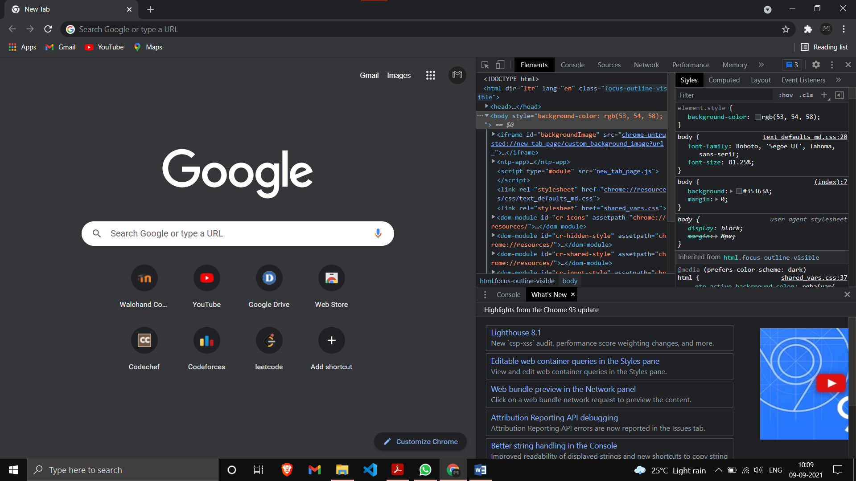  
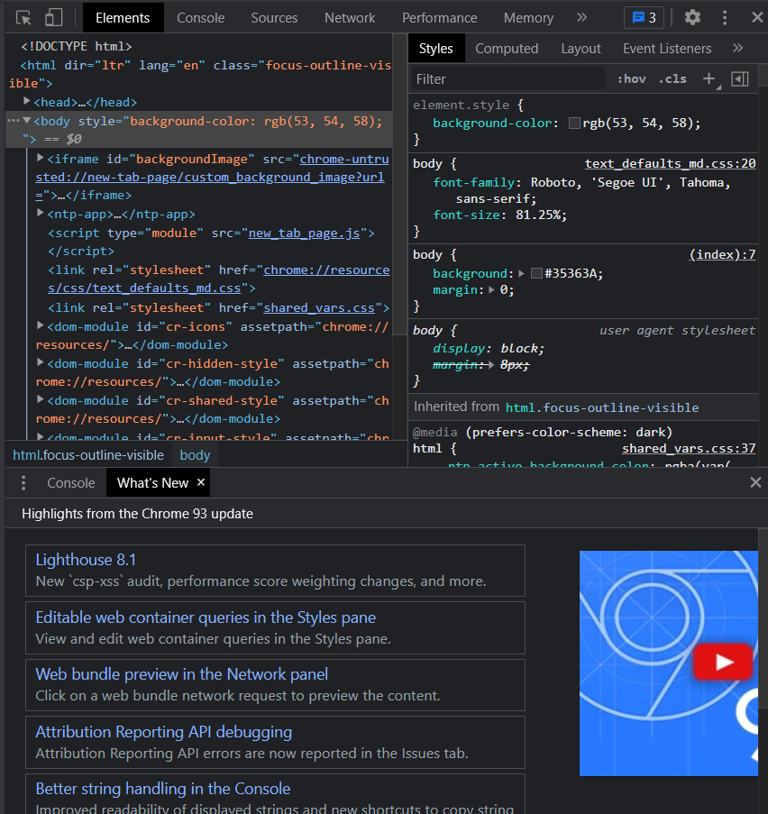

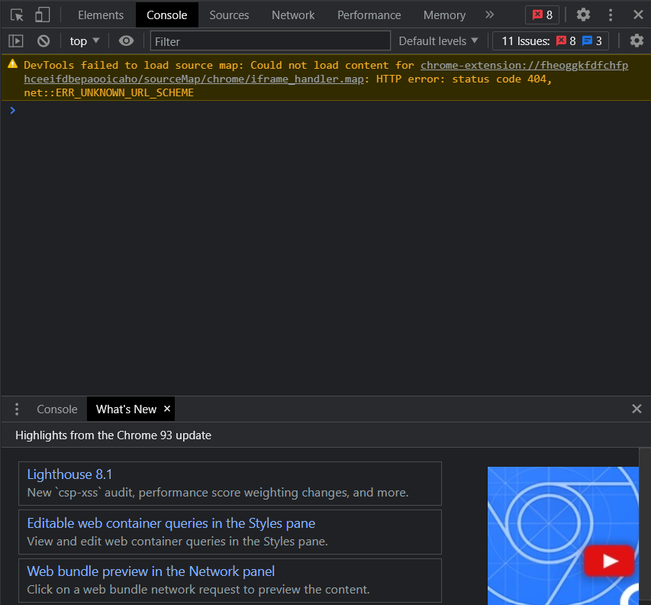

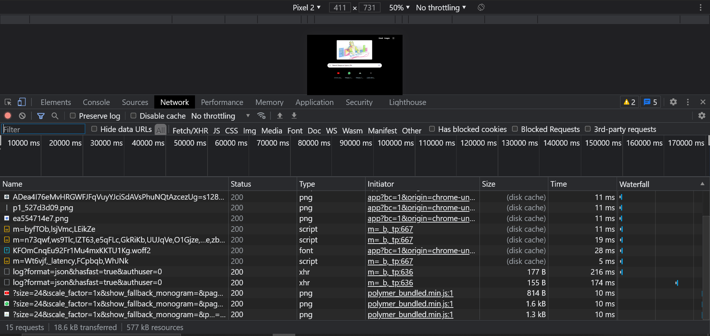

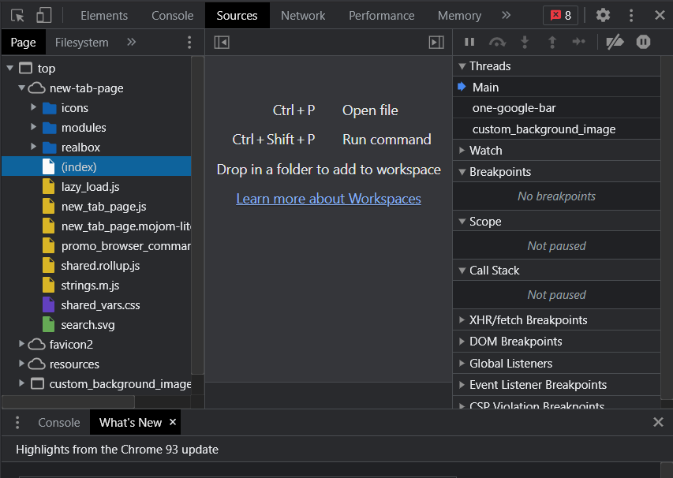

**Brave:**

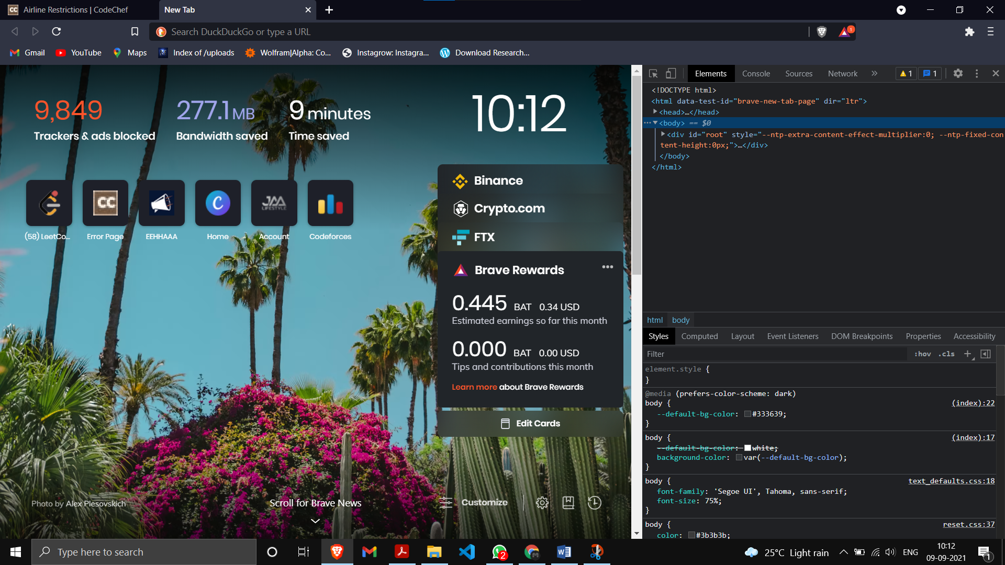  
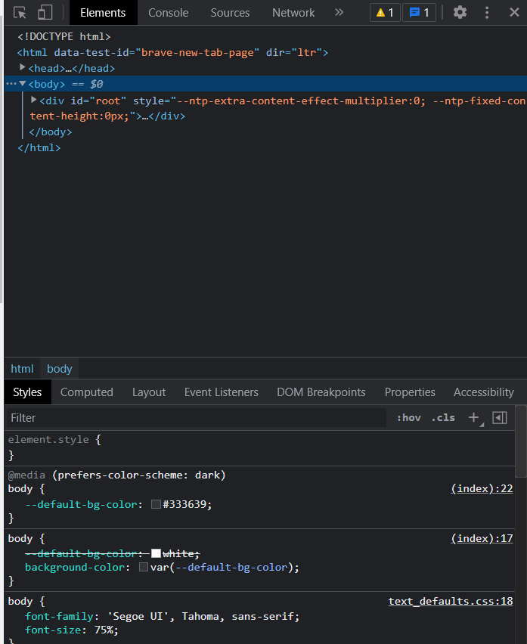

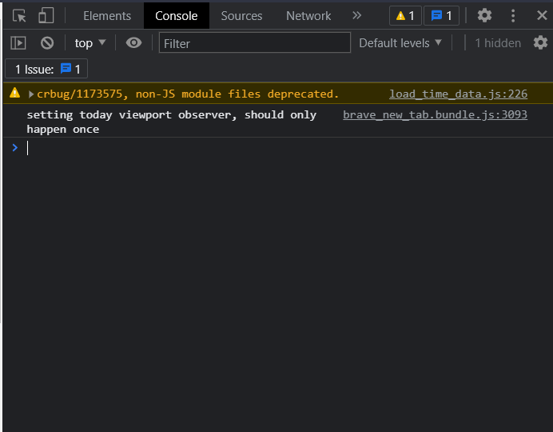  
  
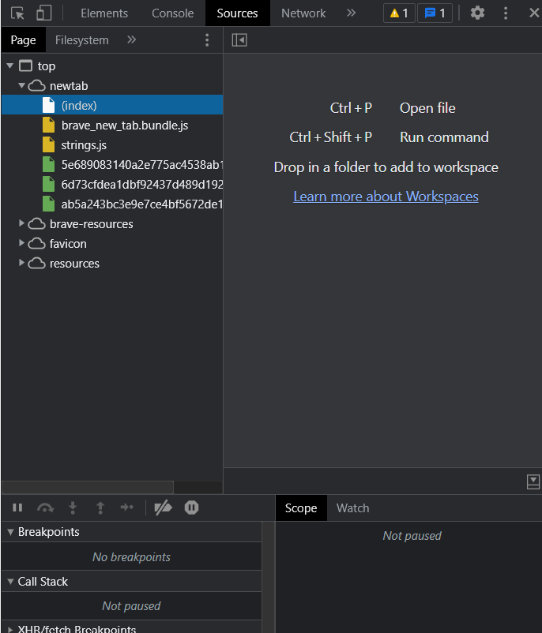

**Problem Statement 2:**

1. Visit https://en.wikipedia.org/wiki/Computer_science on various browsers.

Chrome:

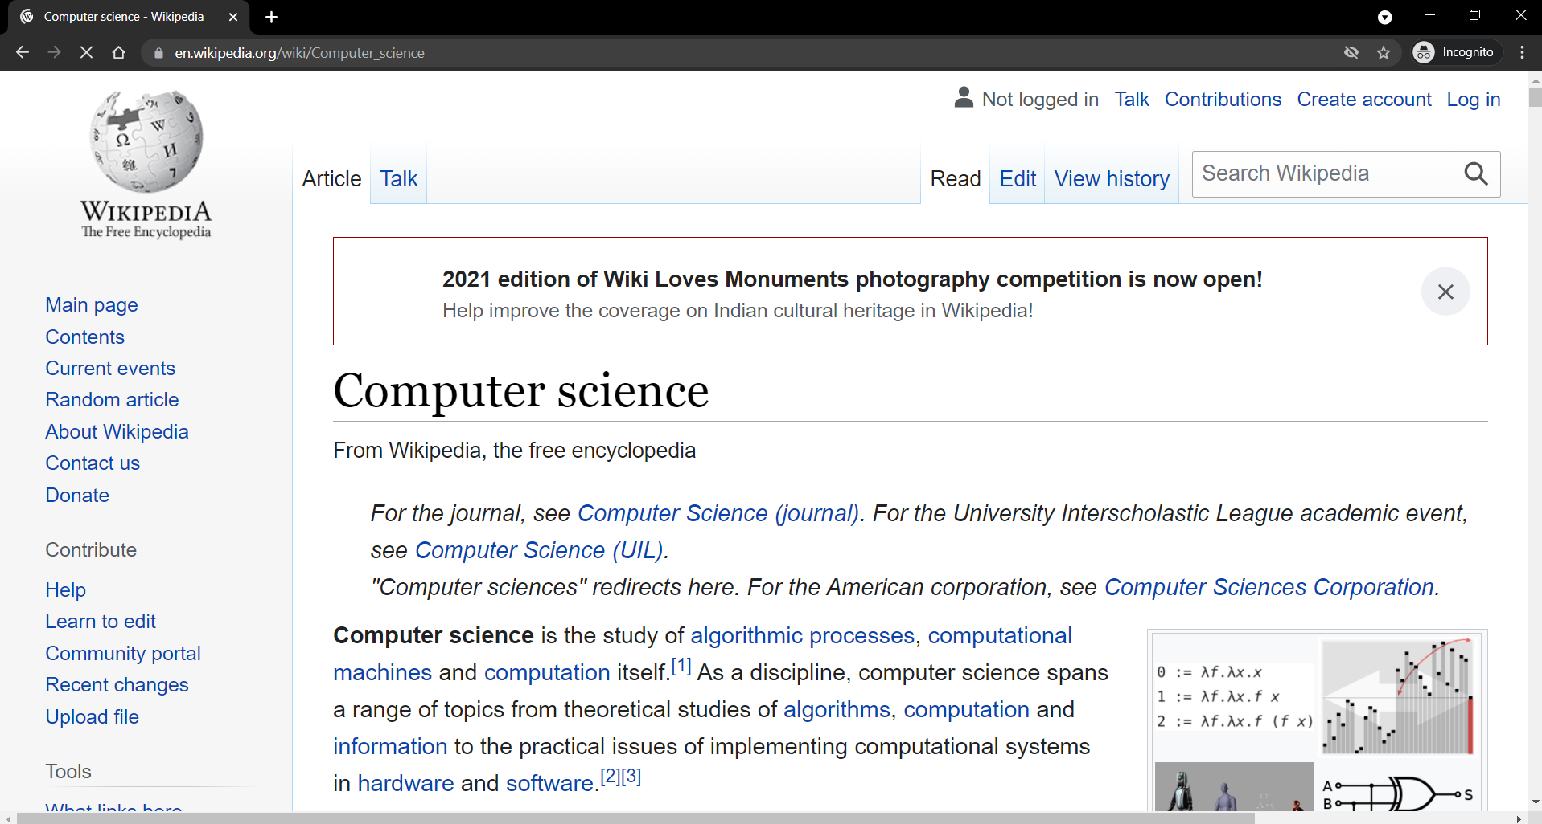

Brave:

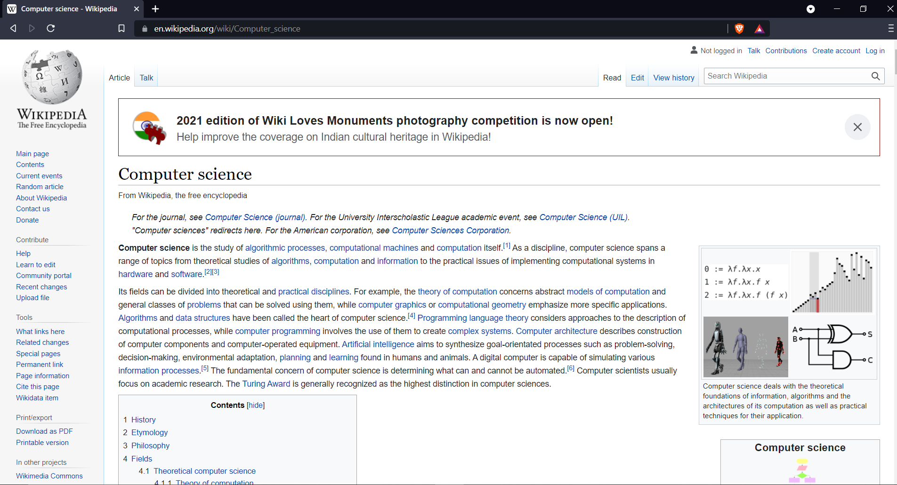

2. Using browser’s Developer Tools option find out how many requests-response cycles are needed to load the page fully on your machine?

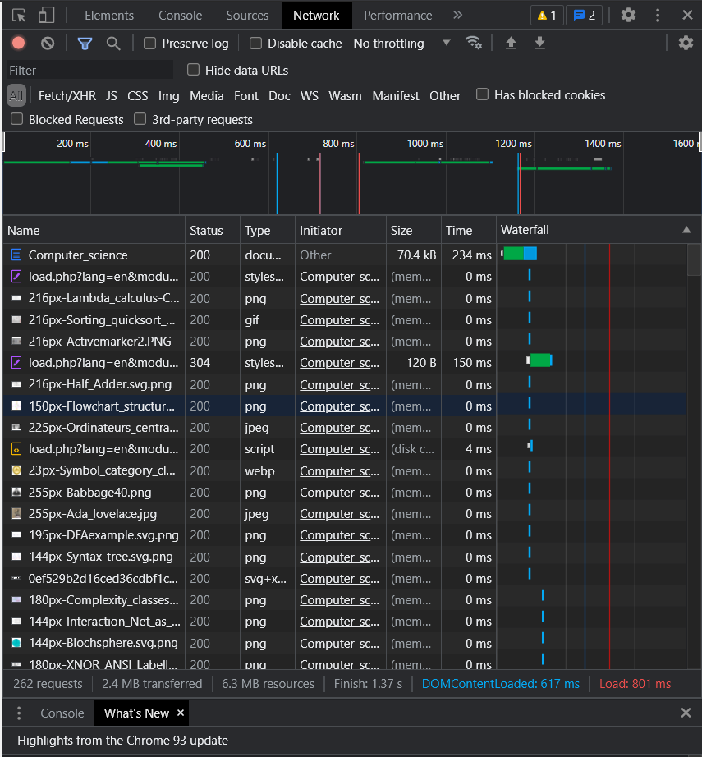

3. Using browser’s Developer Tools option get the header information of the page.

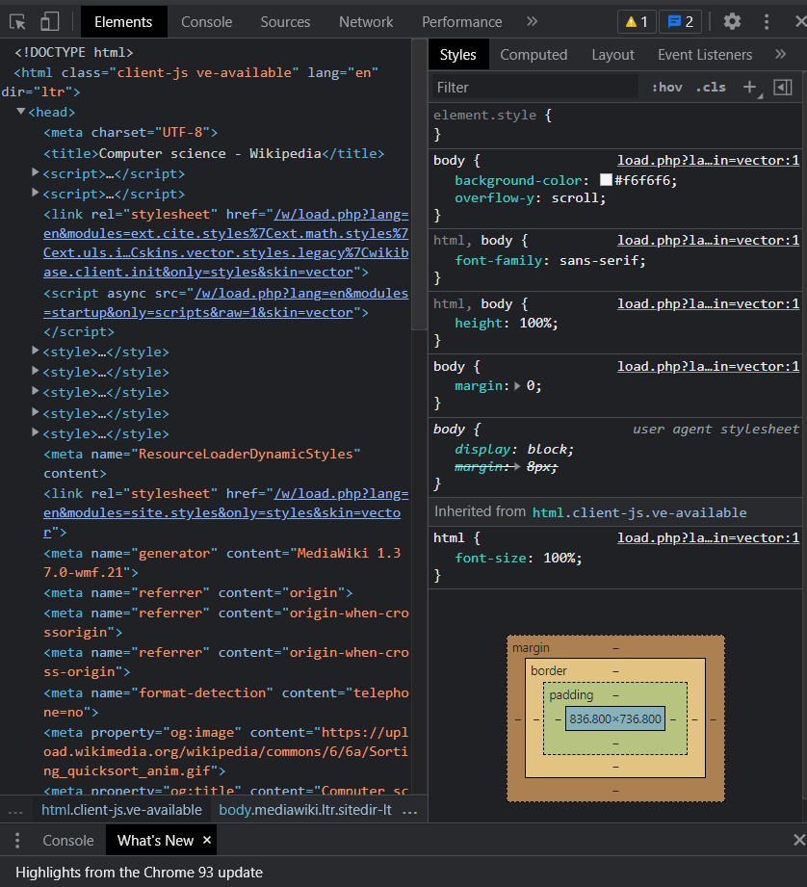

4. Using browser’s Developer Tools option go through the DOM, CSS editor and JavaScript debugger options

DOM:  
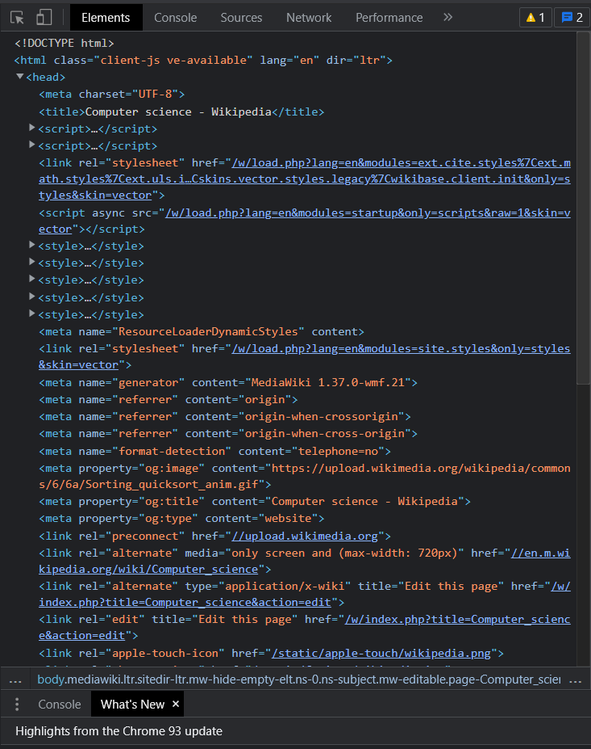  
  
CSS Editor:  
